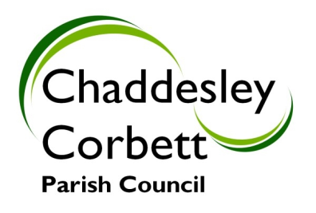

WARNING!!!

We have recently received complaints regarding anti – social behaviour in the Orchard.
We are aware of what is happening and members of the public will be keeping a watch on the area.
We will continue to report any future incidents to the Police.

Thank you,

Rachel Jefferies
Clerk to the Parish Council
clerk@chaddesleyparishcouncil.gov.uk
07405 306071

